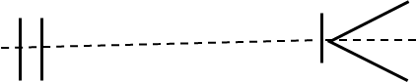

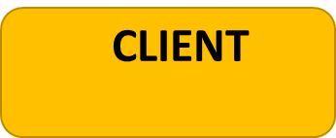

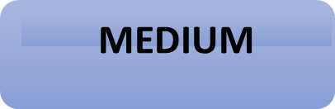

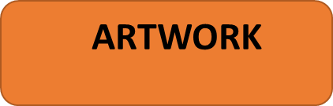
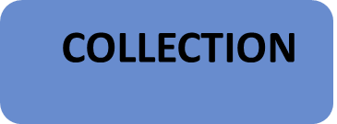
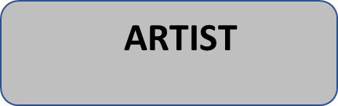
contains
lives
Is created by
Are part of
Is used in
uses
Created
Was sculpted by
contains
uses
contains
is/are part of by

